Lake of Two Mountains High School
EDUCATIONAL PROJECT
2024-2027

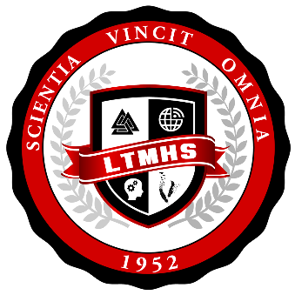

PURPOSE AND DEFINITION OF THE EDUCATIONAL PROJECT 3
LEGAL FRAMEWORK 3
MISSION 4
VISION 4
SCHOOL/CENTRE PROFILE 5
GROUPS INVOLVED IN THE PREPARATION OF THE EDUCATIONAL PROJECT 19
CONSULTATIONS HELD FOR THE PREPARATION OF THE EDUCATIONAL PROJECT 19
POLICY ORIENTATIONS 20
OBJECTIVES 20
SCHOOL/CENTRE OBJECTIVES, INDICATORS AND TARGETS 21
SCHOOL/ CENTRE ORIENTATION 1 22
SCHOOL/ CENTRE ORIENTATION 2 23
SCHOOL/ CENTRE ORIENTATION 3 24
GOVERNING BOARD ADOPTION 25

PURPOSE AND DEFINITION OF THE EDUCATIONAL PROJECT
This educational project is a strategic tool through which Lake of Two Mountains High School has defined its policy orientations, priority actions, and expected results to inform its community in this regard, with a view to ensuring educational success for all students regardless of age. This educational project reflects the characteristics and needs of the students who attend Lake of Two Mountains High School, as well as the community’s expectations with regard to education.

LEGAL FRAMEWORK
The Education Act (EA) states that an institution’s educational project must consist of the following elements (EA, Sections 37 and 97.1):
- A description of the context in which the educational institution acts and the main challenges it faces, particularly with respect to academic success and, in the case of a vocational training centre, the relevance of the training to regional or national labour market needs;
- The specific policy orientations of the educational institution and the objectives selected for improving student success;
- The targets to be achieved by the end of the period covered by the educational project;
- The indicators to be used to measure achievement of these objectives and targets;
- The intervals at which the educational project is to be evaluated, determined in collaboration with the school board;

The Educational Project must also:
- Respect the students’, parents’ and school staff’s freedom of conscience and of religion (EA, Section 37);
- Cover a period that is harmonized with the period covered by the school board’s commitment-to-success plan and the period covered by the MEQ strategic plan (EA, Sections 37.1, 97.2 and 209.1);
- Where applicable, comply with the terms prescribed by the Minister to govern the coordination of the entire strategic planning process between the educational institutions, the school board and the MEQ (EA, Section 459.3);
- Be consistent with the school board’s commitment-to-success plan (EA, Sections 37 and 97.1).

MISSION
At Lake of Two Mountains High School, we aspire to provide a nurturing, supportive, and connected learning environment in order to empower our students with 21st century skills.

VISION
The community at Lake of Two Mountains High School believes that the students learn best when they are technologically and interpersonally connected, provided with authentic learning experiences, and are prepared to succeed in a complex, interconnected, and ever-changing world.

SCHOOL/CENTRE PROFILE
External Environment
Lake of Two Mountains High School, of the Sir Wilfrid Laurier School Board, is situated at 2105 Guy in the town of Deux-Montagnes, about 30km northwest of Montréal. The current structure, built in 1983, replaced the old building of the same name at 203, 14th Avenue which housed the high school and served the anglophone community since 1952.

While bussing is provided by the school board, the school is also accessible by city buses and is located within a ten-minute walk of the Gare Deux-Montagnes train station. A public hockey arena is within walking distance. An elementary school is next to our school and LTMHS rents space to a CPE on its premises. There are other elementary schools in the area as well as a large francophone comprehensive high school nearby.
LTMHS services the communities of Deux-Montagnes, Saint-Eustache, Sainte-Marthe-sur-le-Lac, Saint-Joseph-du-Lac, Mirabel, Pointe-Calumet, and Oka.
As indicated in the document Indices de défavorisation 2017-2018 published by the MEQ, the IMSE*, Indice de milieu socio-économique, for LTMHS is 4, which indicates a fairly socially advantaged milieu.

*The IMSE is made up of the proportion of families with children whose mother does not have a diploma, certificate or grade (which is two thirds of the weight of the index) and the proportion of households whose parents were not employed during the Canadian Census reference week (one third of the weight of the index).

LTMHS has two important community partners that it works with. We have a part-time school nurse as well as a part-time social worker through an entente with the local CSSS. We also have an active 4Korners presence in the school. Students can avail themselves of the services of these professionals through these ententes.

Increasing the level of parent involvement in school is one of the challenges that LTMHS has identified and is seeking to address. A concerted effort was made to start a PPO during the 2018-2019 school year, but work must continue on this initiative. One of our goals is that increased parental involvement in school will translate into increased student engagement in school as well.

Internal Environment
An analysis of the school’s internal environment describes the status of students and their success, staff and organization, and the school.

LTMHS is a high school for students in Secondary 1 to Secondary 5. We offer three specialized programs - AC (Academic Consolidation for Cycle 1), VEE3 (Secondary 3 for repeating students), and Work Oriented Training and Semi-Skilled classes. In addition to regular classrooms, the school contains the following facilities: Science Wing with technology lab, Woodworking lab, Makerspace room, Visual Arts classroom, Music room with soundproofed spaces, student kitchen and breakfast room, double gym, weight room and changing rooms, outdoor fields, resource room, Library, and Cafeteria fitted with stage.
We have also designated a Games Room for Secondary 1 students, and Lounge for senior students.

Enrolment statistics
LTMHS, which has a capacity for over 700 students, has experienced growth in terms of student enrolment over the past 5 years. In 2023, our total enrolment is at 445, equalling that of 2022. We project 448, 442, and 428 respectively over the three coming academic years.
Approximately 9.5% of our students have an EHDAA code and over 30% of our students follow an IEP (Individualized Education Plan).

2022-2023 School Year
School Portrait Gender  Description | Male | Female | Overall
Number of Students | 239 | 206 | 445
Number of Students with an IEP | 82 | 58 | 140
Percent of Students with an IEP | 34.3% | 28.2% | 31.5%
Number of Students with a Code (EHDAA)* | 19 | 11 | 30
Percent of Students with a Code (EHDAA)* | 7.9% | 5.3% | 6.7%

*Data taken from Lumix-Educational Project-High School Dashboard-School Portrait

Staff Characteristics
Over 50% of staff members live in the vicinity of LTMHS. In addition to 34 full-time teaching staff, we have one full-time school principal, one secretary, one full-time receptionist, one part-time Staff-Assistant, one part-time School Organization Technician, one part-time administrative technician, one part-time librarian, one full-time student supervisor, one full-time and one part-time laboratory technician, two janitors, one full-time (class 1) and one part-time, as well as a full-time maintenance worker (class 1).
In order to support our students, we have one part-time guidance counselor, one part-time school psychologist, as well as two full-time Special Education Technicians and four full-time student attendants. Through measures and grants, we are able to increase the services we provide to our students by increasing supporting teachers, special education, and attendant hours.
The stability of the teaching workforce at LTMHS can be characterized as fairly stable, with an average of 16 years of seniority for tenured teachers. We expect this to remain stable over the coming three years given our projected enrolments. We also host several student-teachers every year at all stages of their field experiences. On the whole, teachers and staff are involved in the extracurricular life of the school and many ECA’s are offered to the student population such as hockey, basketball, soccer, volleyball, music, leadership, robotics, woodworking, cooking, and travel to name a few.

Educational Programming
LTMHS is proud to offer a Chromebook 1:1 program wherein all students are provided with a device by the school. Several pedagogical initiatives are tied into academic engagement. Particularly popular are our Robotics Program and our Coding Day Challenge. We have reduced paper waste by providing resources digitally whenever possible, and teachers incorporate the learning management system offered by Google Classroom into their daily practice. Other tools offered by Google for Education that we use for pedagogical purposes include virtual reality tours, augmented reality lessons, video-conferencing, and digital mapping.
We understand the importance of following up on digital learning initiatives by including digital citizenship skills in our practice and helping students create a positive digital footprint for their future.

Student Population and Success Indicators
The vast majority of students at LTMHS are in the Generalized Education Path and close to 79% will obtain their DES at the end of Secondary 5. LTM also offers the WOTP certification for students who meet the criteria for the Pre-Work and Semi-Skilled Pathways.
Below you will find a table with success indicators for both groups.
In general, the vast majority of students leave LTMHS with either certification or qualification.

Last year, of the 61 students enrolled in sec 5 at LTMHS, 40 were admitted to CEGEP, which is a rate of 66%. An additional 7 students were accepted in vocational programs.

Certification and Qualification Success rates
 | 2019-2020 | 2020-2021 | 2021-2022 | 2022-2023
Student enrolment | 61 | 44 | 67 | 61
Certification with Secondary 5 Diploma | 59 | 41 | 59 | 55
Qualification (WOTP and SS) | 4 | 7 | 4 | 7
Graduation rate (Secondary 5 diploma, certificate in WOTP, certificate in SS) | 97% | 93% | 88% | 90%

The student population at LTMHS can be broken down as follows for the 2022-2023 school year:

 | Number  of Students | Percentage  of School Population | Number of Coded Students-per level | Coded Student Percentage  33 total coded students
Secondary 1 | 86 | 19.3 | 11 | 12.7
Secondary 2 | 101 | 22.6 | 5 | 5
Secondary 3 | 95 | 21.3 | 5 | 5
Secondary 4 | 83 | 18.6 | 1 | 1
Secondary 5 | 88 | 19.7 | 6 | 7
Pre- Work and Semi-Skilled | 11 | 0.02 | 5 | 45
*Numbers taken on September 30, 2023

Success Rates for High School Diploma/Qualification

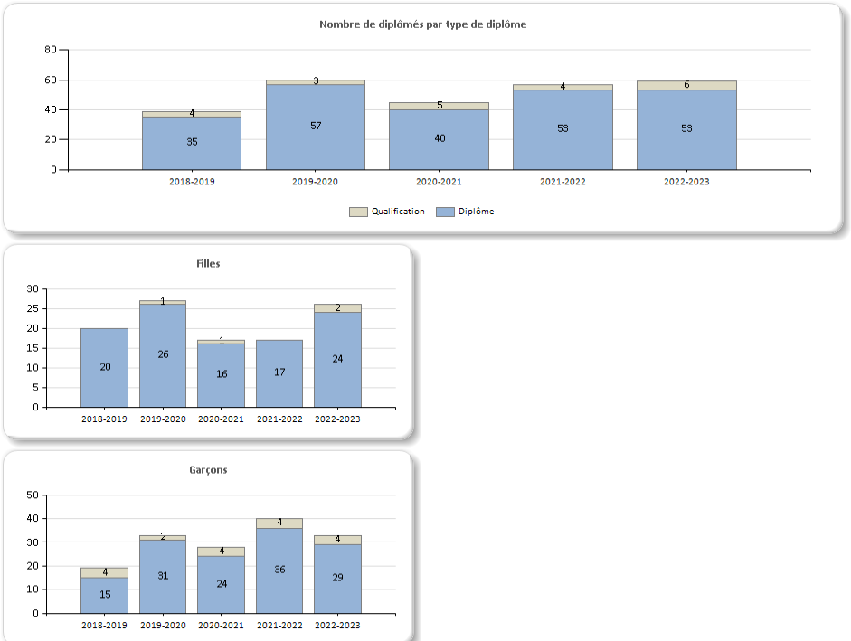
* Taken from Lumix Dashboard

Success Rates for MEQ Uniform Exams

On average, students at LTMHS had performed well on their Secondary 4 and 5 MEQ end of year exams. The 2022/2023 academic year saw a drop in that trend across 4 subject areas.

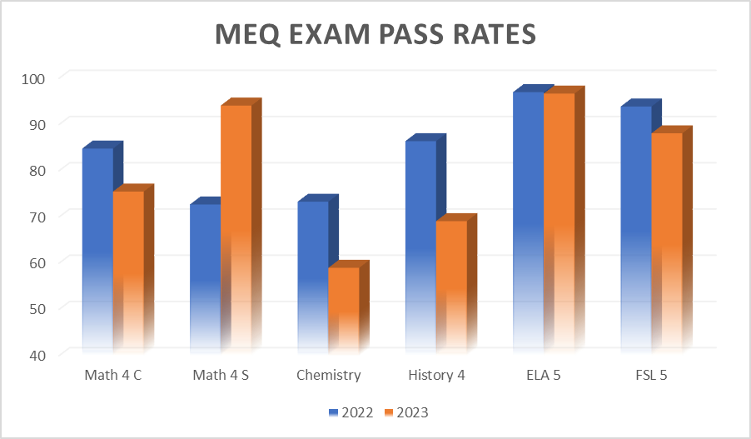
* Data taken from PowerBI

There are also areas of concern in the differences between the school mean grades and those generated by the MEQ exams.

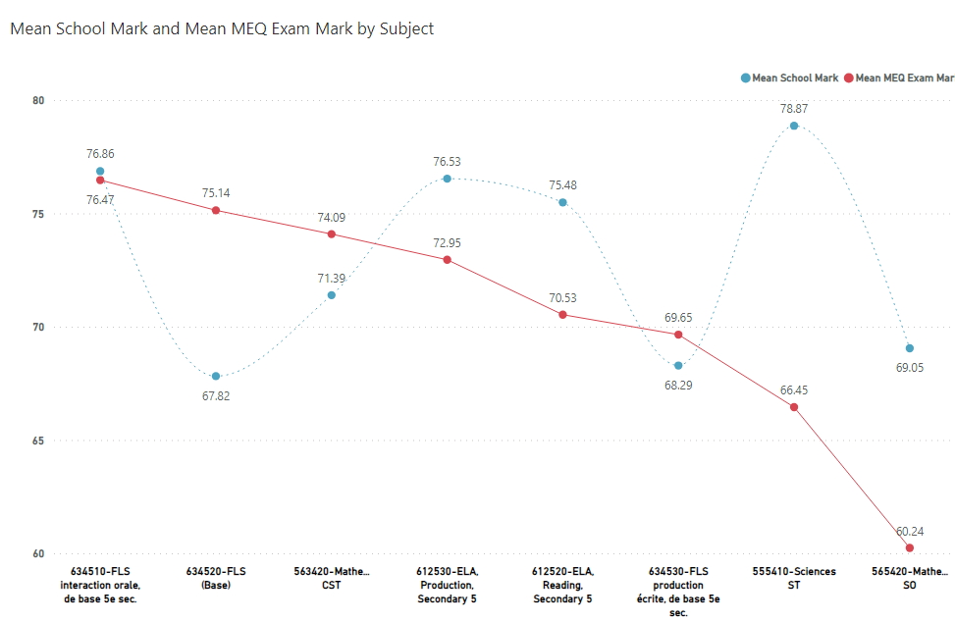

Success Ratios for end of Cycle 1 (Secondary 2) 2023
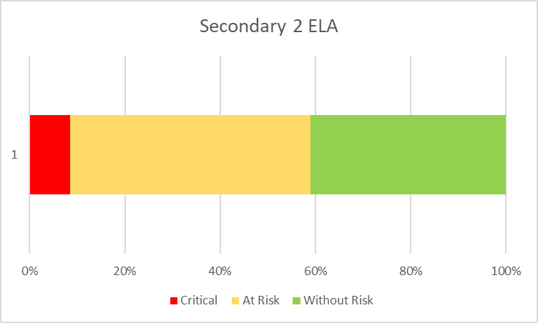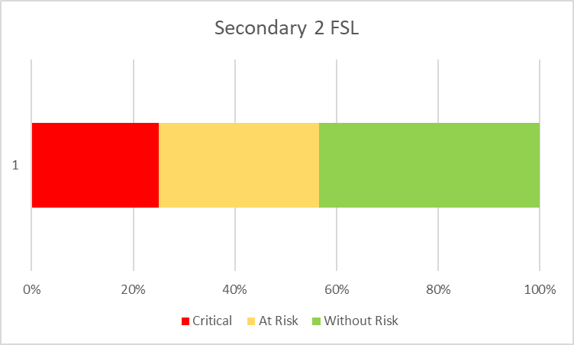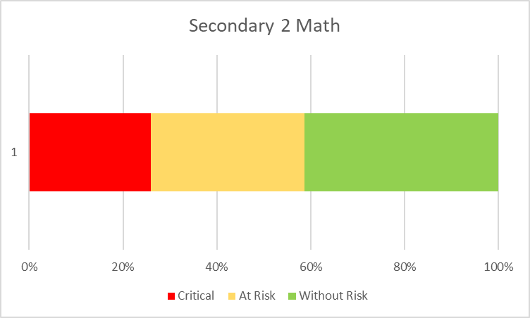

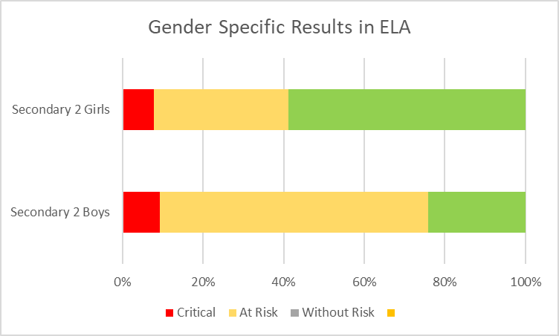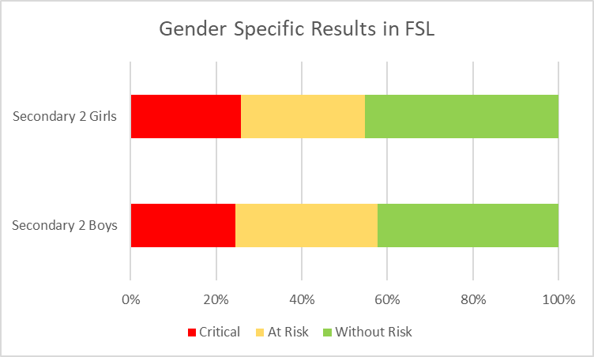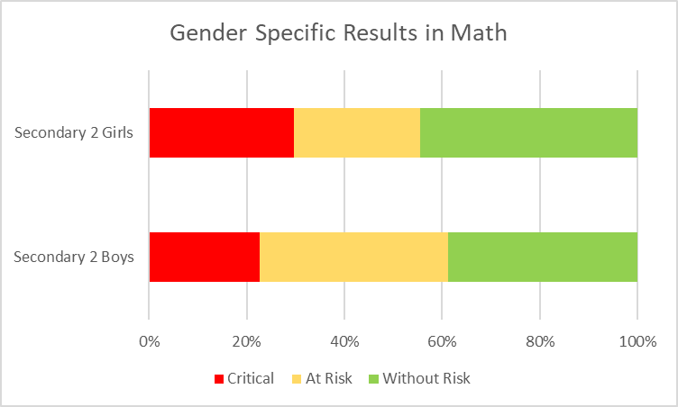

In analyzing our student results for the past three years, the LTMHS Community has identified that the end of cycle results (Secondary 2) for the core subjects of English, Math and French are of particular concern. In each subject area, over 50% of LTMHS students are classified as critical or at risk of failing. Of further concern is the alarming rate of risk in first language learning – particularly for boys. The school team will work on increasing capacity for success in these three subject areas to better prepare students for the challenges of Cycle 2.

Our School Survey:
In order to monitor student engagement in school and students’ perception of bullying and violence, LTMHS conducts the Our School Survey annually. The survey measures student perception on a variety of school climate indicators against the Canadian Norm. In 2023, surveyed students reported that their perception of being safe at school was 41%, whereas the Canadian norm for high school is 57%. This survey will be repeated in the spring of 2024 with the same students to compare data. In the meantime, we will conduct a more directed survey to learn why students do not perceive being safe at school.
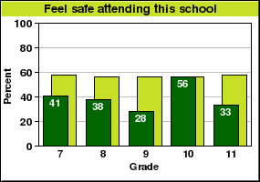

The survey results for 2023 show 26% of students reported being victims of bullying, which is higher than the Canadian norm of 22%. The school’s ABAV plan and ABAV committee are actively put forward to decrease both of these indicators. The charts below illustrate this data:
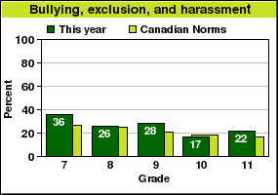
One of the key areas that LTMHS would like to work on in the years to come is increasing the sense of belonging of students within the school community. As illustrated in the results from the Our School Survey from 2023, only 51% of students perceive having a high sense of belonging. The Canadian Norm for High school is 62%. By fostering increased parental involvement in school (PPO), and through a variety of student engagement initiatives (mentoring, restorative practice, student leadership, school-wide activities, extracurricular activities), the school would like to surpass the Canadian Norm:
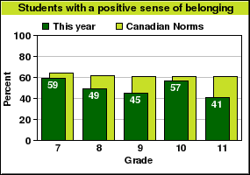

The LTMHS team has noticed an increase in reported cases of anxiety and depression and plans to address student emotional wellbeing through a variety of actions over the years (increase in extracurricular activities and other programs such as mentorship, pet therapy, Achieve Club, and mindfulness). The table below shows that 31% of students at LTMHS perceive having feelings of moderate to high anxiety - 1% below the Canadian norm.

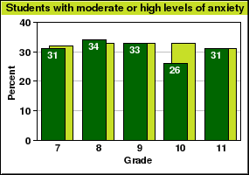
Students with moderate or high levels of anxiety – Students who have intense feelings of fear, intense anxiety, or worry about particular events or social situations. 31% of students in this school had moderate to high levels of anxiety; the Canadian norm for these grades is 32%. 46% of the girls and 17% of the boys in this school had moderate to high levels of anxiety. The Canadian norm for girls is 46% and for boys is 19%.

Through open-ended questions where students were asked to share what they liked about their school, many answered that they appreciated the school size, the after-school activities, the breakfast program and the technology. Areas for improvement that were more frequently commented on were lack of activities to do at lunch time, lack of after-school academic support, as well as lack of understanding at times from staff members on student issues. Students also reported that they felt uncomfortable openly asking for help from staff - a matter that will be discussed and reviewed throughout the year.

Consultations:

LTMHS is committed to working with all of its school stakeholders. As such, when completing our Educational Project, we surveyed parents, staff and students in order to use their insights to drive our educational initiatives for the next three years. Below you will find a summary of the most pertinent data collected in these surveys.

Parents Survey:
A survey was sent to all our families in March 2023, and 40 families responded. The chart summarizes the top answers to the five questions asked.

Survey Questions | Top answers
What are three words you would use to describe LTMHS | Small, Community, Inclusive
What are LTMHS’s greatest strengths | Communication, Activities, Teaching Practices
What is LTMHS’ biggest challenge | Student Motivation
What we need to focus on/improve upon in order to better service students | Increased number of enriched and specialized classes, more extracurricular activities, more service for diverse learners, more academic focus
Why are you choosing LTMHS for your child’s education | School size, English language instruction and child wanting to attend were the most reported reasons

Staff Survey:
A survey was conducted with staff in January 2023, the key points are highlighted below:

STRENGTHS | CHALLENGES | COMMENTS
Key strengths mentioned were our sense of community, supportive, relaxed, spontaneous, welcoming, and open to new ideas and methods. | Key areas of concern expressed included low levels of student motivation and literacy, a sense of being overwhelmed and understaffed, and lacking leadership. | Overwhelmingly, the staff would like to see more activities in the school that foster strong staff/student relationships. There is also strong support for activities directed at specific groups or topics (clubs and sports for female students, prevention for bullying, increased sexuality education, and drug/alcohol prevention).
- Low student motivation (intrinsic motivation)
- Limited availability of quality and qualified staff
- Difficulty accessing professional and social services
- Difficulty with consistency of application of code of conduct
- Major gap between MEQ results and class results
- Literacy

GROUPS INVOLVED IN THE PREPARATION OF THE EDUCATIONAL PROJECT
Committee Members |  |  | Roles
Brent Nadeau |  |  | Principal
Gina Blanchette (Science) |  |  | Teacher
Josée Larose (Math) |  |  | Teacher
Janet Gallagher/Anastasia Nardelli |  |  | Special Education Technician
Jessica Scerio |  |  | Guidance Counselor
Samuel Altarac-Hofmann |  |  | Pedagogical Consultant (SWLSB)

CONSULTATIONS HELD FOR THE PREPARATION OF THE EDUCATIONAL PROJECT
Consultations | Date | Time |  | Location | Details (optional)
Teachers | November 2022 | Introduction at Staff Meeting |  | LTMHS Library | Follow-up survey January 2023
Other Staff Members | January 9, 2023 | 10:00 |  | LTMHS Library | Follow-up Survey January 2023
Students | January 2023 | Grade Level Assemblies |  | LTMHS Cafeteria | Follow-up survey February 2023
Parents | March 2023 | Evening town hall |  | Zoom | Survey provided February 2023
Governing Board | February 7, 2023 | 18:30 |  | Zoom | Community Reps present
Other Stakeholders | February 2023 |  |  | Email Bump | Information Piece

POLICY ORIENTATIONS
Lake of Two Mountains High School aims to ensure student growth and success, both academically and socially, through high-quality instruction and engaging activities.

OBJECTIVES
An objective is your school/centre’s commitment to a priority for the period covered by the educational project. It sets out the precise and measurable changes that the activity of the school/centre should produce. It should contain perceptible and meaningful outcomes for students, youth and adults, and is the basis for accountability.

Objectives | Description
Objective 1 | Increase school-wide student literacy levels in both English and French.
Objective 2 | Increase success rate on Ministry final exams in Secondary 4 and 5.
Objective 3 | Increase sense of belonging at school for students.

SCHOOL/CENTRE OBJECTIVES, INDICATORS AND TARGETS
SCHOOL/CENTRE ORIENTATION
Promoting academic rigour through effective and innovative teaching

MEQ OBJECTIVE/  ORIENTATION | SWLSB  OBJECTIVE/ORIENTATION | SCHOOL/CENTRE OBJECTIVE | INDICATORS | TARGET | MONITORING
MEQ Objective 4  By 2030, increase to 90% the success rate on the composition component of the Elementary 6 (Cycle 3, Year 2) language of instruction ministerial examination in the public system. | SWLSB Objective 4  By 2022, increase the Grade 6 English Language Arts Reading Competency from 90.1% to 92.5% | School Objective 1  To increase the success rates on the MEQ Grade 6 end-of-year Reading Comprehension Assessment | MEQ Grade 6 end-of-year English Language Arts Reading Response Assessment | From 81% in June 2018 to an 87% success rate by June 2022 on the MEQ Grade 6 English Language Arts Reading Response Assessment | Administration along with Cycles 2 and 3 teams review progress every 6 weeks through English Language Arts PLC

SCHOOL/CENTRE ORIENTATION 1
Increase school-wide student literacy levels in both English and French.
MEQ  OBJECTIVE/ORIENTATON | SWLSB  OBJECTIVE/ORIENTATION | SCHOOL/CENTRE OBJECTIVE | INDICATOR(S) | TARGET(S) | MONITORING
MEQ Objective 1 | N/A | Reduce percentage of critical and at-risk students in ELA and FSL. | DIBELS results  End of year assessment results  D-Vision data  GB+ | 5% reduction in the number of critical and at-risk students. | Principal will monitor D-Vision dashboards once a year at the end of the year  Teachers and Principal will monitor DIBELS 3 times a year.  SLSNC tracking of students with IEPs.

SCHOOL/CENTRE ORIENTATION 2
Increased success rate on Ministry final exams in Secondary 4 and 5.
MEQ  OBJECTIVE/ORIENTATON | SWLSB  OBJECTIVE/ORIENTATION | SCHOOL/CENTRE OBJECTIVE | INDICATOR(S) | TARGET(S) | MONITORING
MEQ Objective 2 | SWLSB Objective 3 | Increase MEQ exam results for all core subjects. | MEQ results  Class results per term  MEQ exam Dashboard  More detailed information on 1st communication for students with difficulties | Increase MEQ exam results by 5% and reduce the gap between the MEQ exam results and class results. | Dedicated department meetings to share best practices and align curriculum.  D-Vision.  Mozaïk grade data per term.

SCHOOL/CENTRE ORIENTATION 3
Increase sense of belonging at school for students.
MEQ  OBJECTIVE/ORIENTATON | SWLSB  OBJECTIVE/ORIENTATION | SCHOOL/CENTRE OBJECTIVE | INDICATOR(S) | TARGET(S) | MONITORING
MEQ Objective 3 | SWLSB Objective 3 | Increased sense of belonging and safety at school for all students to match Canadian norms. | Our School Survey.  OIM data.  In-house student survey each term for specificity on belonging and safety. In-house parent surveys twice a year. | Increase sense of belonging by 10%  increase sense of safety at school by 19% | Behaviour team.  Principal/SA/Behaviour Tech.  OIM/ABAV entries.  OIM chart indicators.  Psychologist.  Social Worker.

GOVERNING BOARD ADOPTION
Resolution | G.B. RESOLUTION NUMBER 231205-24. Cynthia Ronci MOVED THAT the 2024-2027 Educational Project be adopted as presented on November 18, 2023.  (date)  Seconded by Lyndon Efford.
Signatures |   Michael Thorburn Brent Nadeau

